1. Image of the initial screen when the storefront is loaded. Customer is asked “What is the item ID of the product you would like to buy?”

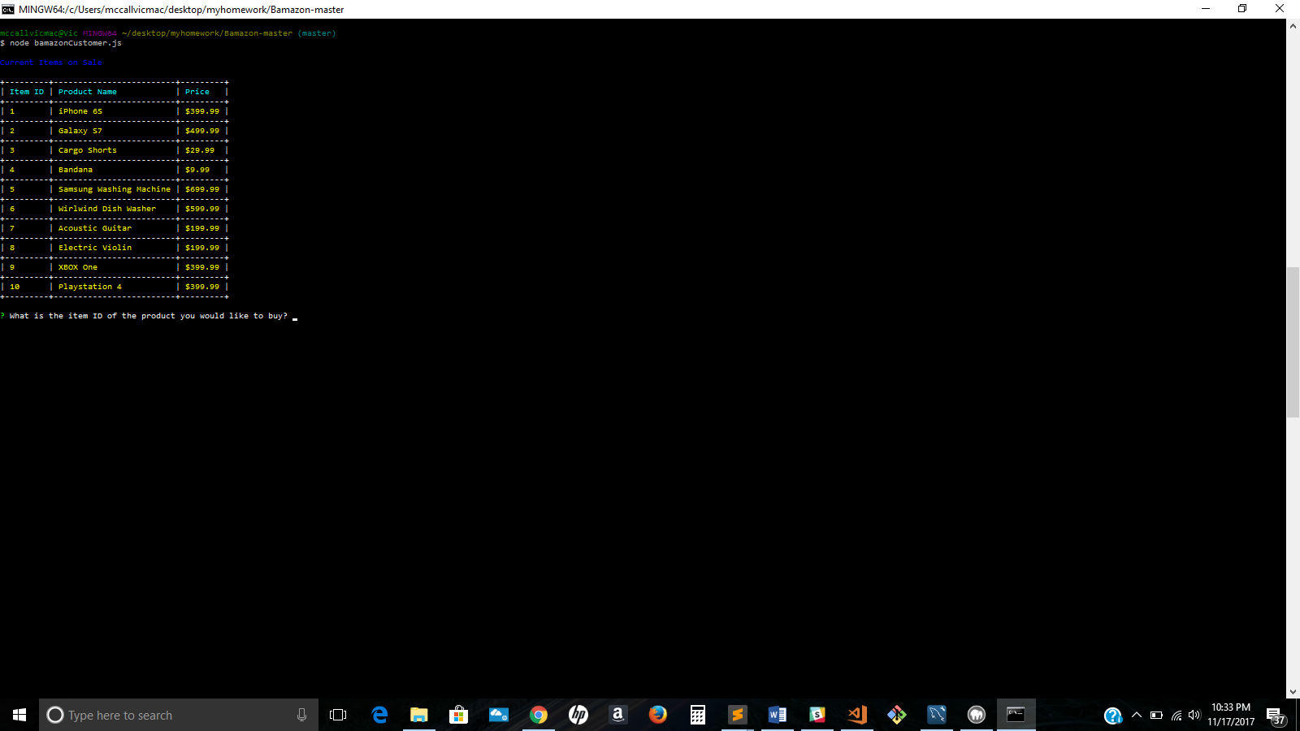

1. After the item ID is selected then the customer is asked “How many would you like to buy?”

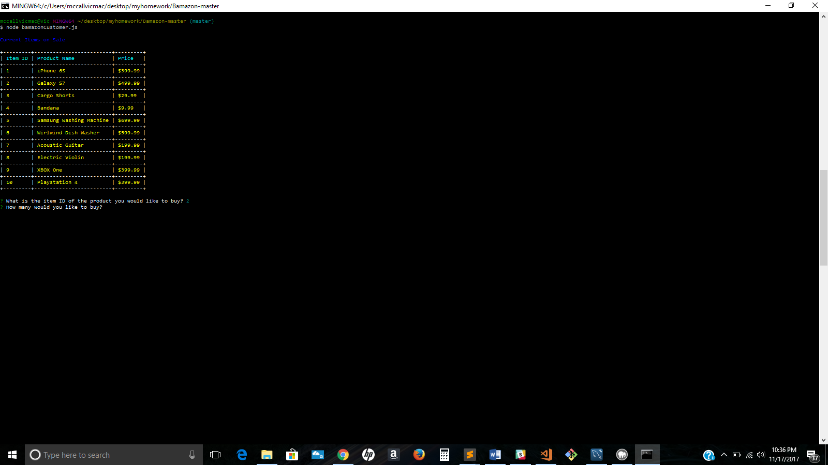

1. Once the quantity is chosen then a total price is given and the following message is given to the customer, “Thank you come again.”

